

用 户

手 册

Version 5.0

Presented by

Baoqi-zhong

User manual

「Desktop Clock」

「Packaging」

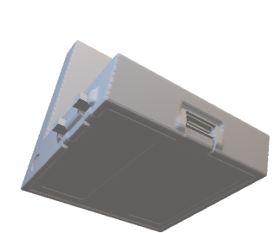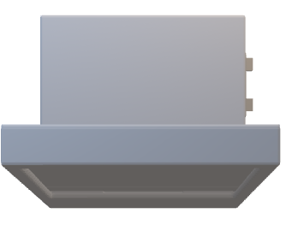·Main product

Type-c

Charging port

- Mode Button

- Add Button

·Type-c Charging cable

·User manual

「Quick Start」

·Press Mode Button to switch the mode

among : Clock / Countdown /

Calendar / Information Page .

「Clock」

Class start/ending time

6 50

PM 7:00

:

·Press Add button to switch between

12-hour and 24-hour.

·Adjust time：

·Long press Mode button till the numbers start to blink.

·Press Add button will add the number

blinking by one.

·Press Mode button to edit minutes.

·Long press Mode button to exit.

「Countdown」

Date Day

253

9.27 Tuesday today

高考还有 天

英英化生物 语数化生

·To adjust the date and day, see Clock Mode.

·It’ll automatically show tomorrow's class schedule after 6 PM everyday, and show '' tomo '' at upper right corner.

「Calendar」

Date Day

·To adjust the date and day, see Clock Mode.

·The the current date will be highlighted .

12.24 Saturday

「Other」

left out

·It’s still under development so I'm sorry for many imperfections.

·It is recommended to charge it once a month. You have to reset the time after the battery is dead.

·You can contact me to add functions.

·Everything has been open sourced in GitHub. See:

<https://github.com/baoqi-zhong/Desktop-clock>

Version 5.0